BLUE Solutions:
8:
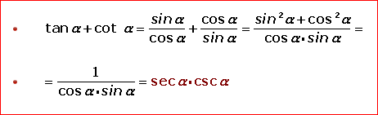

9:
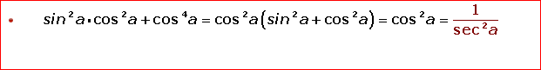

10:
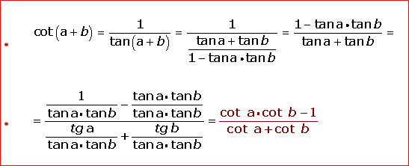

GREEN solutions:
8:
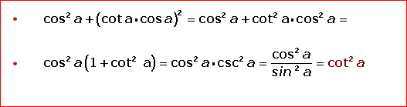

9:

10:
