*PRINT IN BLACK AND WHITE *Glue on BLUE PAPER

1.

2.

3.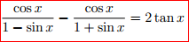

4. 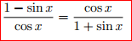 5.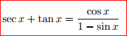

6.

*Glue on BLUE PAPER

7. 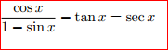

8.

9. 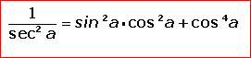

10. 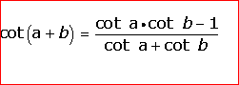

*Glue on GREEN PAPER

1.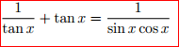

2. 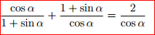

3. 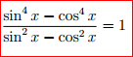 4. 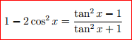

5. 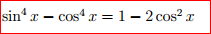

6. 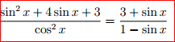
*Glue on GREEN PAPER

7. 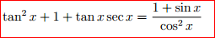

8.

9.

10. 